

**ANNA UNIVERSITY REGIONAL CAMPUS COIMBATORE-641046**

**NAAN MUDHALVAN COURSE**

**PHASE 5**

|  |  |
| --- | --- |
| **NAME** | MOHAMED SIRAJDEEN A |
| **NAAN MUDHALVAN REGISTER NO.** | au710021106019 |
| **DOMAIN** | CLOUD COMPUTING |
| **PROJECT** | E-COMMERCE APPLICATION ON IBM CLOUD FOUNDRY |

**ABSTRACT:**

Online **FOOD DELIVERY SYSTEM** is a website designed primarily for use in the food delivery industry. This system will allow hotels and restaurants to increase scope of business by reducing the labor cost involved. This system allows to quickly and easily manage an online menu which customers can browse and use to place orders with just few clicks. Restaurant employees then use these orders through an easy to navigate graphical interface for efficient processing.

# PROCEDURE TO RUN THE CODE IN Visual Studio:

**Step 1:**

Createanew**Folder Name:**“Online food delivery system"onyourcomputer.

# Step 2:

# LaunchVisualStudioandopenthefolderintheeditor.

# Step 3:

Insidethefolder,createa**new HTML file**named"food.html".

# Step 4:

**Save** the file.

# Step 5:

**Open**the**"food.html"**filein the browser and the web page will be visible there.

**HTML CODE:**

**Home.html**

<!DOCTYPE html>

<html lang="en">

<head>

<meta charset="UTF-8">

<meta name="viewport"

content="width=device-width, initial-scale=1.0">

<link rel="stylesheet" href="styles.css">

</head>

<body>

<section class="showcase-area" id="showcase">

<div class="showcase-container">

<h1 class="main-title" id="home">Eat and Treat</h1>

<p>Eat Healty, it is good for our health.</p>

</div>

</section>

<div class="padding-container">

<hr>

<nav id="navbar">

<ul id="navcontent">

<li><a href="home.html">Restaurants</a></li>

<li><a href="#contact">ContactUs</a></li>

<p>"Part of the secret of success is to eat what you like and let the food fight it out inside"</p>

</ul>

</nav>

</div>

<div id="container1">

<div id="row1">

Welcome to Online FoodShop

</div>

<button class="btn">ORDER NOW</button><br />

<div id="container3">

<div id="row2">

<button class="btn">Prices</button><br />

</div>

<div id="row3">

<button class="btn">Specials</button><br />

</div>

</div>

</div>

<section id="contact">

<h2>Contact Us</h2>

<p>Email: info@eatandtreats.com</p>

<p>Phone: +91 9629876534</p>

</section>

<footer>Copyright © 2020-2021 OnlineFoodShop.

All Rights are reserved</footer>

</body>

</html>

**Page1.html**

<!DOCTYPE html>

<html lang="en">

<head>

<meta charset="UTF-8">

<meta name="viewport" content="width=device-width, initial-scale=1.0">

<link rel="stylesheet" href="styles.css">

<title>Online Food Delivery</title>

</head>

<body>

<header>

<h1>Food Delivery</h1>

<p>Your favorite food, delivered to your door.</p>

</header>

<section id="food-menu">

<h2 class="food-menu-heading">Food Menu</h2>

<div class="food-menu-container container">

<div class="food-menu-item">

<div class="food-img">

<img src="https://curlytales.com/wp-content/uploads/2022/02/burgers-8.jpg" alt="" />

</div>

<div class="food-description">

<h2 class="food-titile">BURGER</h2>

<p>

Hamburger, a food consisting of one or more cooked PATTIES, placed inside a sliced bread roll or bun roll. Cheeseburger, a hamburger with added cheese(s).

</p>

<p class="food-price">Price: &#8377; 250</p>

</div>

</div>

<div class="food-menu-item">

<div class="food-img">

<img src="https://encrypted-tbn0.gstatic.com/images?q=tbn:ANd9GcSQJqEMksF4A3izAQMMFpEsF3PI-xm2jWEGmA&usqp=CAU"

alt="error"

/>

</div>

<div class="food-description">

<h2 class="food-titile">PIZZA</h2>

<p>

A pizza loaded with a spicy combination of Harissa sauce, PeriPeri chicken chunks and delicious pasta.

</p>

<p class="food-price">Price: &#8377; 250</p>

</div>

</div>

<div class="food-menu-item">

<div class="food-img">

<img src="https://hips.hearstapps.com/hmg-prod/images/chicken-fried-rice-horizontal-1545488885.png?crop=0.8893333333333334xw:1xh;center,top&resize=1200:*" alt="" />

</div>

<div class="food-description">

<h2 class="food-titile">CHICKEN RICE</h2>

<p>

Chicken fried rice is the comfort dish of Chinese food.

</p>

<p class="food-price">Price: &#8377; 250</p>

</div>

</div>

<div class="food-menu-item">

<div class="food-img">

<img src="https://i.ytimg.com/vi/MhzBUy-JOCE/maxresdefault.jpg" alt="" />

</div>

<div class="food-description">

<h2 class="food-titile">CHICKEN NOODLES</h2>

<p>

Chicken noodles are a delicious flavor packed meal of stir fried noodles, chicken, vegetables and sauces

</p>

<p class="food-price">Price: &#8377; 250</p>

</div>

</div>

<div class="food-menu-item">

<div class="food-img">

<img src="https://images.hindi.news18.com/ibnkhabar/uploads/2021/08/masala-dosa-recipe-e1630574482215.jpg" alt="" />

</div>

<div class="food-description">

<h2 class="food-titile">DOSA</h2>

<p>

Dosa is a popular South Indian thin crepe made with fermented rice and lentil batte

</p>

<p class="food-price">Price: &#8377; 150</p>

</div>

</div>

<div class="food-menu-item">

<div class="food-img">

<img src="https://encrypted-tbn0.gstatic.com/images?q=tbn:ANd9GcRt4LygVTmYcqL7dpCO0lGTM65i16J7ebfjaQ&usqp=CAU" alt="" />

</div>

<div class="food-description">

<h2 class="food-titile">SHAWARMA</h2>

<p>

SHAWARMA is a sandwich especially of sliced lamb or chicken, vegetables, and often tahini wrapped in pita bread

</p>

<p class="food-price">Price: &#8377; 250</p>

</div>

</div>

</div>

</section>

<footer>

<li><a href="ibm.html">Home</a></li>

<li><a href="home.html">Restaurant</a></li>

<li><a href="menu.html">Menu</a></li>

<p>&copy; 2023 Restaurant Name. All rights reserved.</p>

</footer>

</body>

</html>

**Style.css**

/* External Style Sheet */

body {

font-family: Arial, sans-serif;

background-image: url('https://eatatbento.com/wp-content/uploads/2022/04/Bento-Food-Light-Background.jpg'); /* Replace 'background.jpg' with your image file */

background-size: cover;

background-color: #f0f0f0;

line-height: 1.0;

margin: 0;

padding: 0;

}

.showcase-area {

height: 50vh;

background: linear-gradient(

rgba(240, 240, 240, 0.144),

rgba(255, 255, 255, 0.336)

),

url("https://i.postimg.cc/wT3TQS3V/header-image2.jpg");

background-size: cover;

background-position: center;

background-repeat: no-repeat;

}

.showcase-container {

display: flex;

flex-direction: column;

align-items: center;

justify-content: center;

height: 100%;

font-size: 1.6rem;

}

header {

background-color: #009688;

color: #fff;

text-align:center;

padding: 10px;

}

nav ul {

background-color: #009688;

list-style-type: none;

text-align: center;

padding: 20px 0;

}

nav li {

display: inline;

margin-right: 10px;

}

nav a {

text-decoration: none;

color: #fff;

}

main {

max-width: 900px;

margin: 50px auto;

padding: 70px;

background-color: #fff;

box-shadow: 0 0 10px rgba(0, 0, 0, 0.1);

}

#food {

padding: 5rem 0 10rem 0;

}

#food h2 {

text-align: center;

font-size: 2.5rem;

font-weight: 400;

margin-bottom: 40px;

text-transform: uppercase;

color: #555;

}

.food-container {

display: flex;

justify-content: space-between;

}

.food-container img {

display: block;

width: 100%;

margin: auto;

max-height: 300px;

object-fit: cover;

object-position: center;

}

.img-container {

margin: 0 1rem;

position: relative;

}

.img-content {

position: absolute;

top: 70%;

left: 50%;

transform: translate(-50%, -50%);

opacity: 0;

z-index: 2;

text-align: center;

transition: all 0.3s ease-in-out 0.1s;

}

.img-content h3 {

color: #fff;

font-size: 2.2rem;

}

.img-content a {

font-size: 1.2rem;

}

.img-container::after {

content: "";

display: block;

position: absolute;

top: 0;

left: 0;

width: 100%;

height: 100%;

background: rgba(0, 0, 0, 0.871);

opacity: 0;

z-index: 1;

transform: scaleY(0);

transform-origin: 100% 100%;

transition: all 0.3s ease-in-out;

}

.img-container:hover::after {

opacity: 1;

transform: scaleY(1);

}

.img-container:hover .img-content {

opacity: 1;

top: 40%;

}

/* .........../Food Menu/............ */

.food-menu-heading {

text-align: center;

font-size: 3.4rem;

font-weight: 400;

color: #666;

}

.food-menu-container {

display: flex;

flex-wrap: wrap;

padding: 50px 0px 30px 0px;

}

.food-menu-container img {

display: block;

width: 250px;

height: 250px;

border-radius: 50%;

object-fit: cover;

object-position: center;

}

.food-menu-item {

display: flex;

flex: 1 1 600px;

justify-content: space-evenly;

margin-bottom: 3rem;

}

.food-description {

margin: auto 1.5rem;

}

.font-title {

font-size: 1.8rem;

font-weight: 400;

color: #444;

}

.food-description p {

font-size: 1.4rem;

color: #555;

font-weight: 500;

}

.food-description .food-price {

color: #117964;

font-weight: 700;

}

footer {

text-align: center;

padding: 30px;

background-color:#009688;

color: #fff;

}

**Code Explanation**

Document Type Declaration (`<!DOCTYPE html>`):

- This declaration specifies that the document follows HTML5 standards.

1. <html>` Element:

- The root element that encloses the entire HTML document.

- The `lang` attribute is set to "en" to indicate the document's language as English.

1. <head>` Element:

- Contains metadata and information about the document.

1. `<meta>` Elements:

- `charset="UTF-8"` sets the character encoding to UTF-8, ensuring proper text rendering.

- `name="viewport"` defines a viewport for responsive web design.

External CSS Link:

- `<link>` element references an external CSS file named "styles.css" for styling the web page.

1. `<body>` Element:

- Contains the visible content of the web page.

1. `<section>` Element with the class "showcase-area":

- It represents a section of the page, possibly a showcase area.

- Contains a heading (`<h1>`) and a paragraph (`<p>`).

1. `<div>` Element with the class "padding-container":

- Wraps content for styling purposes and contains an `<hr>` element.

1. `<nav>` Element with the id "navbar":

- Represents a navigation bar.

- Contains an unordered list (`<ul>`) with list items (`<li>`) for navigation links.

1. Paragraph Element (`<p>`) within the navigation:

- Contains a text that appears to be a quote.

1. `<div>` Element with the id "container1":

- Contains a welcome message and an "ORDER NOW" button.

**Buttons:**

1. `<button>` elements with class "btn" that are used for actions.

- Some buttons have line breaks (`<br>`) following them.

1. `<section>` Element with the id "contact":

- Represents a section for contact information.

- Contains a heading (`<h2>`) and two paragraphs with email and phone contact details.

1. `<footer>` Element:

- Contains copyright information.

This HTML structure defines the layout and content of a simple web page, which appears to be related to online food ordering. Styling and functionality are expected to be provided by the "styles.css" file and any additional JavaScript or server-side code. The content and design can be further customized and enhanced as needed for a complete website**.**

**OUTPUT:**

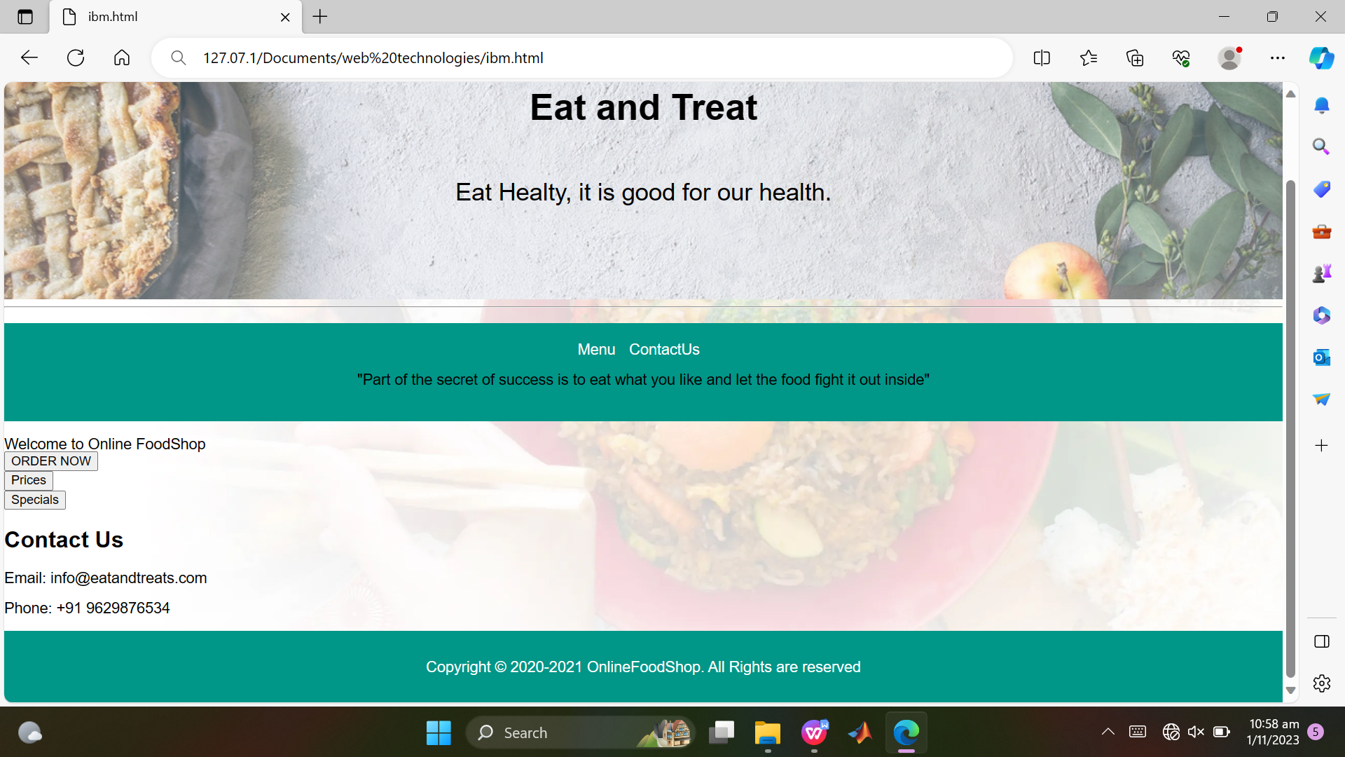

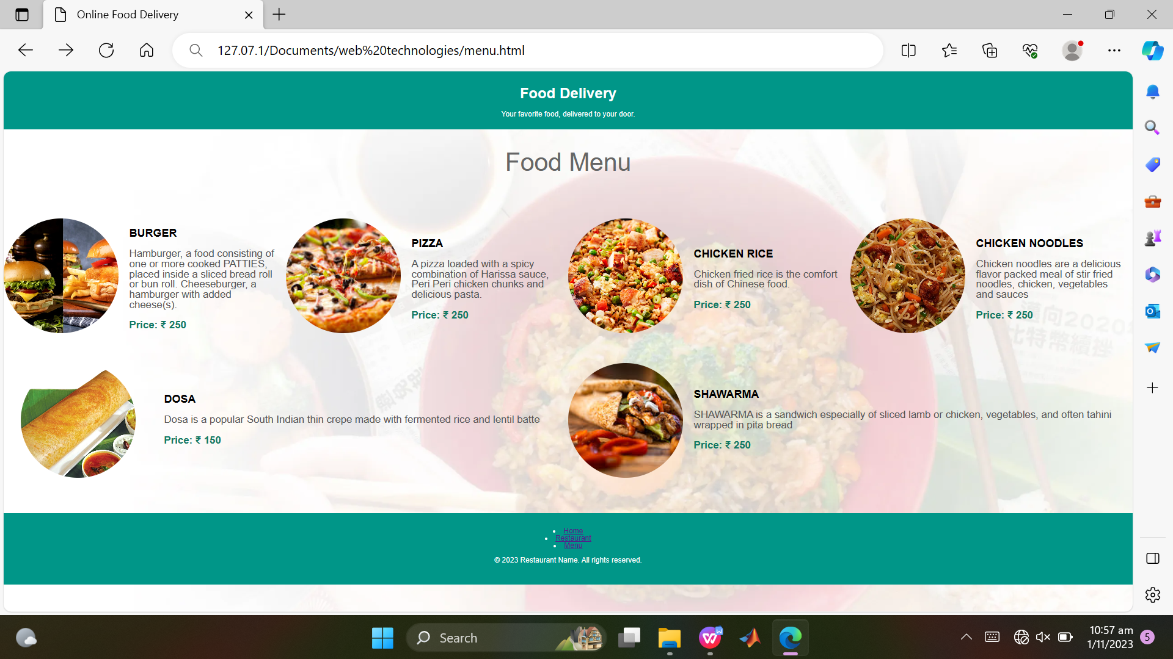

**CONCLUSION:**

With online food ordering system, restaurant an mess menu online can be set up and customers can easily place order. This is achieved through an easy to use graphical interface menu options. The users can add any number of items to the cart from any of the available food categories. We have created website in focus of future food ordering system, this website will helpful to many people.